

REAL – TIME PHISHING LINK DETECTION USING MACHINE LEARNING

MINI PROJECT REPORT
ADNAN SHANAVAS ICE23CC005
IMRAN HARIS ICE23CC023
ANOOP P VINOD ICE23CC012

in partial fulfillment for the award of the degree of

BACHELOR OF TECHNOLOGY IN
COMPUTER SCIENCE AND ENGINEERING (CYBER SECURITY) APJ ABDUL KALAM TECHNOLOGICAL UNIVERSITY
MARCH 2026

DEPARTMENT OF ARTIFICIAL INTELLIGENCE AND CYBER SECURITY

BONAFIDE CERTIFICATE

This is to certify that the project report entitled “REAL – TIME PHISHING LINK DETECTION USING MACHINE LEARNING” is a Bonafide record of the project report presented by ADNAN SHANAVAS (ICE23CC005), IMRAN HARIS (ICE23CC023), ANOOP P VINOD (ICE23CC012) during the academic year 2025 - 2026 towards the partial fulfillment of the requirement of the award of Bachelor of Technology Degree in Computer Science and Engineering (Cyber Security) of APJ Abdul Kalam Technological University, Thiruvananthapuram.

PROF. ASLA MP
PROF. NAVEEN K
PROF. ASHANA YOOSAF

Assistant Professor
Department of AD&CC

Project Coordinators

Dr. ROSNA P HAROON

Professor & HOD
Department of AD&CC

Head of the Department

PROF. ASHANA YOOSAF

Assistant Professor
Department of AD&CC

Project Guide

DECLARATION

We Adnan Shanavas, Imran Haris, Anoop P Vinod hereby declare that, this project report entitled

“REAL – TIME PHISHING LINK DETECTION USING MACHINE LEARNING” is the
Bonafide work of us carried out under the supervision of Prof. Asla M P, Prof. Ashana Yoosaf and Prof. Naveen K. We declare that to the best of our knowledge, the work report here in does not form part of any project report or dissertation the basis of which a degree or award was conferred on an earlier occasion on any other candidate the content of this report is not being presented by any other student to this or any other university for the award of degree.

Signature:
Name of Student: ADNAN SHANAVAS University Register No: ICE23CC005

Signature:
Name of Student: IMRAN HARIS University Register No: ICE23CC023

Signature:
Name of Student: ANOOP P VINOD University Register No: ICE23CC012

Signature:
Name of Guide: PROF. ASHANA YOOSAF

Signature:
Name of Coordinators: PROF. ASLA M P
PROF. NAVEEN K
PROF. ASHANA YOOSAF

Signature:
Countersigned with Name: Dr. ROSNA P HAROON
HOD & Professor, ARTIFICIAL INTELLIGENCE AND CYBER SECURITY
Ilahia College of Engineering and Technology

Date:
Place: Muvattupuzha

ACKNOWLEDGEMENT

Apart from the efforts, the success of this project report depends largely on the encouragement and guidelines of many others. We take this opportunity to express our gratitude to the people who have been instrumental in the successful completion of this project.
We would like to show our heartfelt gratitude towards Prof. Dr. K.A NAVAS, Principal, Ilahia College of Engineering and Technology, granting us permission to work this project. Also, we would like to show our greatest gratitude towards our Head of the Department of Artificial Intelligence and Cyber Security, Dr. ROSNA P HAROON and Project guide Prof. ASHANA YOOSAF, our project coordinators Prof. ASLA M P, Prof. NAVEEN K, Prof. ASHANA YOOSAF for their valuable advice and guidance.
Finally, we express our gratitude and thanks to all our teachers and other faculty members of the Department of Artificial Intelligence and Cyber Security, for their sincere and friendly cooperation in completing this project.

Date:
Place: Muvattupuzha
ADNAN SHANAVAS ANOOP P VINOD IMRAN HARIS

Phishing attacks have become one of the most prevalent cybersecurity threats, often leading to data breaches, financial loss, and compromised user privacy. Traditional blacklist-based detection methods fail to identify newly generated or zero-day phishing URLs, creating a critical need for intelligent and adaptive security solutions. This project proposes a real-time phishing link detection system that leverages machine learning algorithms to accurately classify URLs as legitimate or malicious. The model is trained using a comprehensive dataset of phishing and benign URLs, extracted through lexical, host-based, and content-based features. Techniques such as Logistic Regression, Random Forest, or Gradient Boosting are evaluated to identify the most effective model. The trained model is integrated into a lightweight real-time detection pipeline that instantly analyses incoming URLs and provides immediate risk assessments. Experimental results demonstrate high accuracy and low latency, making the system suitable for deployment in browsers, email filters, and enterprise security platforms. This solution significantly enhances user protection by detecting phishing attempts proactively and efficiently.

CHAPTER TITLE PAGE No.
- INTRODUCTION 1
- LITERATURE SURVEY 2
- PROPOSED SYSTEM 5
  - INTRODUCTION
  - ADVANTAGES
  - DISADVANTAGES
- SYSTEM REQUIREMENTS 7
  - HARDWARE REQUIREMENTS
  - SOFTWARE REQUIREMENTS
  - EXPECTED SYSTEM REQUIREMENTS
  - FEASIBILITY STUDY
  - WORK PLAN
- SOLUTION METHODOLOGY 12
  - ARCHITECTURE DESIGN
  - USE CASE DIAGRAM
  - DATA FLOW DIAGRAM
  - ACTIVITY DIAGRAM

CHAPTER TITLE PAGE No.
- IMPLEMENTATION 16
  - OVERVIEW
  - FRONTEND IMPLEMENTATION
  - BACKENT IMPLEMENTATION
  - MACHINE LEARNING MODEL
IMPLEMENTATION
  - WORKNIG PROCESS
  - TOOLS AND TECHNOLOGIES
USED
  - SYSTEM ADVANTAGES
- RESULT 19
  - RUNNING BACKEND
  - TURNING EXTENSION ON
  - VALIDATING WHEATHER URL
IS SCAME OR NOT

- FUTURE SCOPE 24
- CONCLUSION 25
- REFERENCE 26
- APPENDIX 28

AI – Artificial Intelligence
ML – Machine Learning
URL – Uniform Resource Locator
HTTP – HyperText Transfer Protocol
HTTPS – HyperText Transfer Protocol Secure
DNS – Domain Name System
API – Application Programming Interface
UI – User Interface
UX – User Experience
RF – Random Forest
CSV – Comma Separated Values
HTML – HyperText Markup Language
CSS – Cascading Style Sheets
JS – JavaScript
IP – Internet Protocol
SSL – Secure Sockets Layer
TLS – Transport Layer Security

Figure No. | Figure Name | Page No.
5.1 | ARCHITECTURE DESIGN | 12
5.2 | USE CASE DIAGRAM | 13
5.3 | SEQUENCE DIAGRAM | 14
5.4 | ACTIVITY DIAGRAM | 15
7.1 | RUNNING BACKEND | 19
7.2 | TURNING EXTENSION ON | 20
7.3 | VALIDATING URL | 21
7.3.1 | URL IS SAFE | 22
7.3.2 | URL IS SCAM | 23

CHAPTER 1 INTRODUCTION

In today’s digital world, the rapid growth of the internet has made online communication and transactions easier, but it has also increased the risk of cyber threats. One of the most common and dangerous threats is phishing, where attackers use fake websites and deceptive links to trick users into revealing sensitive information such as passwords, bank details, and personal data.

Traditional methods of detecting phishing attacks, such as blacklist-based systems, are not always effective because they fail to identify newly created or unknown malicious websites. This creates a need for more intelligent and real-time detection mechanisms.

This project, titled “Phishing Link Detector Extension Using Machine Learning,” aims to address this issue by developing a smart browser extension that can identify and warn users about phishing links instantly. The system uses machine learning techniques to analyze various features of a URL, such as its length, structure, use of special characters, and security indicators like HTTPS.

By integrating the trained model into a browser extension, the system provides real-time alerts to users when a suspicious link is detected. This helps in enhancing user awareness, preventing data theft, and improving overall cybersecurity. The project focuses on delivering a lightweight, efficient, and user-friendly solution to combat phishing attacks effectively.

Furthermore, the system can continuously improve its accuracy by learning from new data and evolving phishing techniques over time. This makes the solution adaptable, scalable, and more effective in protecting users against emerging cyber threats.

CHAPTER 2 LITERATURE SURVEY

PhishHaven – An Efficient Real-Time AI Phishing URLs Detection System (Maria Sameen, Kyunghyun Han, Seong Oun Hwang, 2024)
This paper presents an efficient real-time phishing detection system using an ensemble machine learning approach that combines multiple techniques such as lexical URL analysis, HTML encoding, and tiny URL detection. The system achieves high accuracy (around 98%) and supports multi-threading for fast processing. Its importance lies in demonstrating how combining multiple models can significantly improve phishing detection performance in real- time systems. However, it mainly relies on URL features and may fail to detect advanced attacks that use legitimate-looking URLs with malicious content.

Efficient Chrome Extension for Phishing Detection using Machine Learning (Leand Thaci, Arbnor Halilli, 2024)
This paper focuses on developing a browser extension that detects phishing websites in real time using machine learning algorithms like Random Forest, SVM, and KNN. It highlights practical implementation by integrating phishing detection directly into user browsing activity. The importance of this work lies in its real-world usability and demonstration of how machine learning models can be embedded into browser environments for instant protection. However, it is limited to browser-based systems and requires continuous updates to remain effective against evolving threats.

AI-Powered Fraud Detection in E-Commerce (Manasa A S, Ashish L, 2024)
This paper explains how AI systems analyze transactions in real time using behavioral analysis and device fingerprinting to detect fraud. It highlights advantages such as adaptive learning, fewer false positives, and improved customer trust. The importance of this work is that it shows how AI can enhance security in online transactions and reduce fraud risks in growing e-commerce platforms. However, challenges like privacy concerns, bias risks, and high implementation costs are also identified.

E-Commerce Fraud Detection with Machine Learning (Abed Mutemi, Fernando Bacao, 2024)
This study explores machine learning and data mining techniques such as Artificial Neural Networks and Random Forest for detecting different types of fraud, including phishing and spam. It emphasizes scalability and adaptability to new fraud patterns. The importance of this paper lies in showing the effectiveness of ML models in handling large-scale fraud detection problems. However, it also highlights limitations like algorithm bias, limited coverage, and complexity in implementation.

Vulnerability Evaluation in E-Commerce (Mimi Wang, Zhijun Ding, Peihai Zhao, 2024)
This paper focuses on identifying hidden vulnerabilities in e-commerce systems, particularly

those related to third-party payments and unobservable user actions. It provides a framework for detecting unseen risks and improving system security. The importance of this research is that it goes beyond detection and addresses underlying system weaknesses, helping in designing more secure e-commerce platforms. However, it is resource-intensive and limited in scope.

Secure E-Commerce Scheme
(Sena Efsun Cebeci, Kubra Nari, Enver Ozdemir, 2024)
This paper proposes a secure e-commerce framework aimed at protecting user data, reducing communication costs, and avoiding repeated data entry. It enhances efficiency while maintaining strong security. The importance of this work lies in balancing security and cost- effectiveness, making it practical for real-world applications. However, it is mainly protocol- based and may require updates to handle new cyber threats.

AI-Enabled Comprehensive Survey of Phishing Attack Detection Techniques (Sivakumar Nagarajan, 2024)
This survey paper reviews various machine learning and deep learning approaches used in phishing detection and compares their methodologies. It identifies best practices and highlights strengths and weaknesses of different techniques. The importance of this paper is that it provides a comprehensive overview of the field, helping researchers understand existing methods and avoid common mistakes when designing new systems. However, it is theoretical and lacks practical implementation.

Phishing Webpage Detection – Threat Landscape and Detection Techniques (Aditya Kulkarni, Vivek Balachandran, Tamal Das, 2024)
This study presents a taxonomy of phishing detection methods, including URL-based, content-based, and visual-based techniques. It analyzes emerging threats and evolving attack strategies. The importance of this paper lies in highlighting the need for hybrid detection approaches that combine multiple techniques for better accuracy. It also identifies research gaps and opportunities for innovation in phishing detection systems.

State of the Art in AI-Based Phishing Detection
(Mohammed Alghneim, Gamal Alkawsi, Christopher R. Barnhart, 2025)
This paper reviews advanced AI techniques such as deep learning, hybrid models, and boosting algorithms used in phishing detection. It also discusses key challenges like evolving threats, data imbalance, and computational efficiency. The importance of this work lies in presenting the latest advancements and guiding future research toward scalable, adaptive, and high-accuracy phishing detection systems. It emphasizes continuous learning and multi- source data integration for improved performance.

AI Enhanced Phishing Detection System (P. Chinnasamy et al., 2024)
This paper presents a phishing detection system that uses machine learning and NLP to analyze emails, websites, and user interactions. It improves accuracy by going beyond URL- based detection and using contextual and behavioral analysis. Its importance lies in providing comprehensive, real-time protection, though it requires high computational resources.

COMAPRISON TABLE
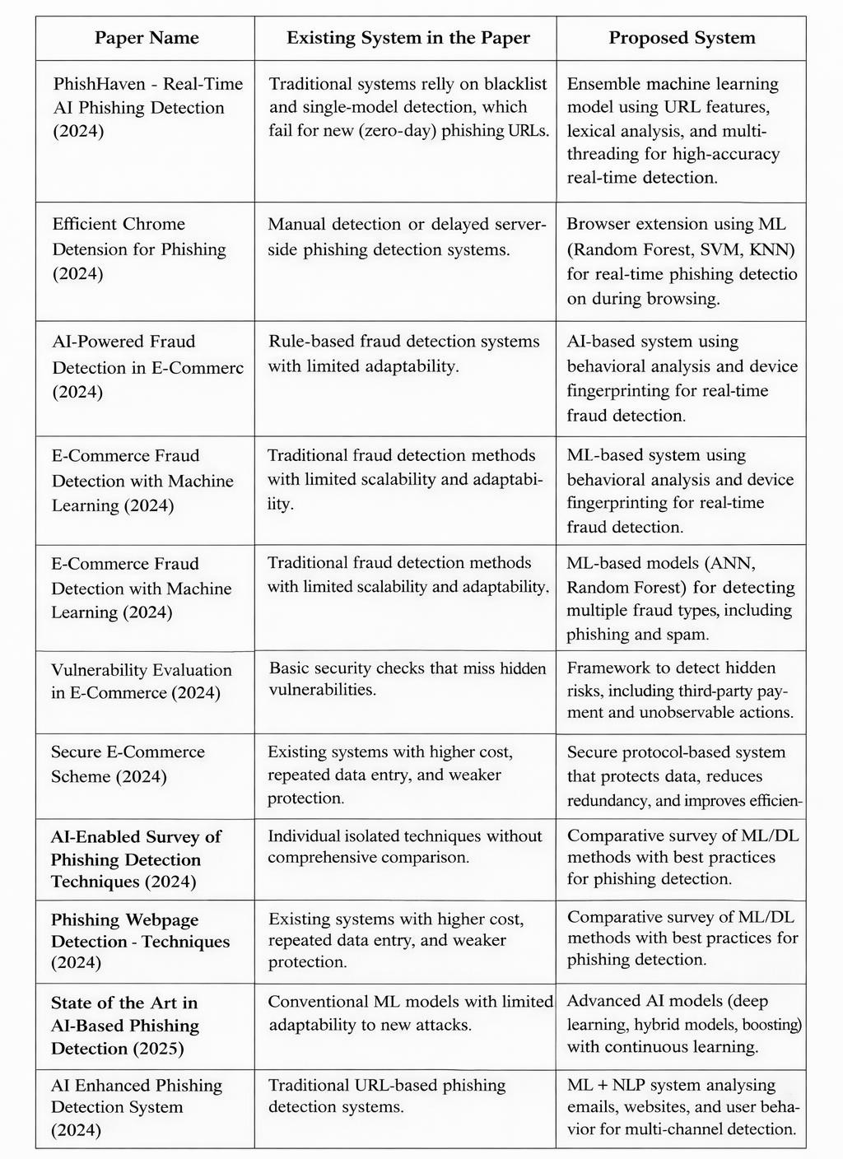

  - Introduction

CHAPTER-3

PROPOSED SYSTEM

The proposed system is a real-time phishing link detection system using machine learning designed to protect users from malicious and fake websites. Unlike traditional systems that rely only on blacklists, this system uses a Random Forest-based model to analyse multiple features of a URL and detect phishing attempts instantly.
The system works through a browser extension, where the URL visited by the user is sent to a backend server. The machine learning model evaluates various parameters such as URL length, domain details, HTTPS usage, and special characters. Based on this analysis, the system provides an instant alert indicating whether the link is safe or a phishing threat.
The system includes a frontend (browser extension), backend server, machine learning classifier, and a real-time alert mechanism. This approach helps overcome the limitations of existing systems by enabling fast, accurate, and real-time phishing detection.
  - Advantages
- Provides real-time detection of phishing links
- Can detect new (zero-day) phishing URLs without relying on blacklists
- Uses machine learning, so it adapts to new attack patterns
- High accuracy due to Random Forest algorithm
- Gives instant alerts to users while browsing
- Works as a lightweight browser extension
- Enhances user security and data protection
- Capable of handling large datasets and multiple URL features
- Reduces human effort by automating detection

  - Disadvantages

- Requires training data and regular model updates
- May produce false positives or false negatives in some cases
- Depends on feature extraction quality
- Backend processing may cause slight delay in response
- Needs internet connection for real-time analysis
- Implementation can be complex for beginners
- May not fully detect advanced content-based phishing attacks

CHAPTER-4

SYSTEM REQUIREMENTS

HARDWARE REQUIREMENTS:
Monitor: Minimum 7inch LED monitor Processor: Pentium or above

SOFTWARE REQUIREMENTS:

Operating System: Sure, in normal format, the Linux distribution (e.g., Ubuntu Server LTS) is known for its security features and stability.

Server: NGINX or Apache for serving web content and managing secure connections via HTTPS. Node.js environment is chosen for running the BioSecureCert application, selected for its efficiency and support for JavaScript.

Cryptography: SHA-256 (Secure Hash Algorithm 256-bit) is a cryptographic hash function for implementing secure cryptographic operations.

Version control: Git for version control. Database: MongoDB for database.
Deployment: CI/CD using Github Action

EXPECTED SYSTEM REQUIREMENTS
The expected system requirements outline the primary functions and behaviors the system should fulfill to ensure its successful operation. These requirements define how the BioSecureCert system is expected to perform from a functional perspective.

REQ 1: User Registration and Authentication
    - Description: Users must be able to register and log in using biometric authentication (facial recognition or fingerprint).

    - Input: Biometric data (face scan or fingerprint).
    - Output: Successful authentication and access to the system.

REQ 2: Certificate Issuance
    - Description: Certificate Issuers should be able to generate and issue digital certificates linked to biometric data.
    - Input: User details and verified biometric authentication.
    - Output: Encrypted digital certificate with a unique QR code.

REQ 3: Certificate Storage
    - Description: Issued certificates should be securely stored in a tamper-proof database with encryption.
    - Input: Generated digital certificate and encrypted biometric data.
    - Output: Secure storage and retrieval capability from the database.

REQ 4: Certificate Verification
    - Description: Verifiers must be able to scan the QR code or use biometric data to verify certificate authenticity in real time.
    - Input: QR code or certificate ID, biometric input.
    - Output: Verification result (Valid / Invalid / Revoked).

REQ 5: Certificate Revocation and Update
    - Description: Issuers should have the ability to revoke or update certificates when necessary.
    - Input: Certificate ID and issuer authorization.
    - Output: Status update of the certificate (Revoked/Updated).

REQ 6: Security and Data Privacy
    - Description: The system must ensure data privacy and security, including the encryption of all biometric and personal data.
    - Input: Biometric data, certificate details.
    - Output: Secure data handling and compliance with privacy regulations.

  - FEASIBILITY STUDY:
The feasibility study for BioSecureCert evaluates the practicality and effectiveness of implementing a tamper-proof biometric certificate generation and verification system. The study analyzes the system from multiple perspectives, including technical, operational, economic, legal, and schedule feasibility.

Technical Feasibility
- The system is developed using reliable and established technologies such as Node.js, React.js, MongoDB, and WebAuthn API for biometric authentication.
- The use of AES-256 encryption and SHA-256 hashing ensures robust security.
- The system architecture is modular and scalable, allowing for easy future enhancements.
- Biometric devices and software libraries are readily available and compatible with the proposed solution.

Operational Feasibility
- Certificate Issuers can easily create and manage digital certificates using a secure and user- friendly dashboard.
- Certificate Holders can store and share their credentials securely.
- Verifiers (employers, institutions) can verify certificates instantly using QR codes or biometric validation.
- The system provides real-time verification, significantly reducing manual verification time and administrative effort.

Economic Feasibility
- The system reduces operational costs by automating verification processes and preventing certificate fraud.
- The initial investment is justified by the long-term benefits, including enhanced security and institutional credibility.
- Deployment on cloud platforms minimizes infrastructure costs and provides scalable solutions.

Legal Feasibility
- The system complies with data privacy laws and regulations, including GDPR and IT Act guidelines.

- Biometric data is handled securely, with end-to-end encryption and restricted access, ensuring legal compliance in handling sensitive information.
- Digital certificates are signed and verified according to recognized standards, maintaining legal validity.

Schedule Feasibility
- The project timeline is realistic and achievable, with key phases such as requirement analysis, development, testing, and deployment completed within 4 to 5 months.
- The system can be implemented with available resources and technologies, ensuring timely delivery.

WORK PLAN:
The development of the BioSecureCert: Tamper-Proof Biometric Certificate Generation and Verification System was planned and executed in a systematic manner. The project was divided into several phases to ensure smooth progress and timely completion. The following work plan outlines the major tasks carried out during the development process.

Requirement Analysis & Feasibility Study
  - Gather functional and non-functional requirements
  - Analyze system feasibility (technical, operational, economic, legal)
  - Duration: 1 Week

System Design
  - Create system architecture and workflow diagrams
  - Design Use Case, Sequence, and Activity Diagrams
  - Design the database schema
  - Duration: 2 Weeks

Backend Development
  - Develop RESTful APIs using Node.js and Express.js
  - Implement MongoDB database integration
  - Apply role-based access control (RBAC)
  - Duration: 3 Weeks

Biometric Authentication Integration
  - Implement facial and fingerprint recognition using OpenCV and WebAuthn
  - Encrypt and securely manage biometric data
  - Duration: 2 Weeks

Frontend Development
  - Design and implement dashboards for issuers, holders, and verifiers
  - Build a user interface using React.js
  - Duration: 2 Weeks

Certificate Generation & QR Code Implementation
  - Generate digital certificates with embedded biometric data
  - Implement QR codes for quick verification
  - Duration: 1 Week

Encryption & Security Layer Implementation
  - Apply AES-256 encryption and SHA-256 hashing
  - Implement secure data transmission (SSL/TLS)
  - Duration: 1 Week

Testing & Debugging
  - Perform functional, integration, and security testing
  - Test biometric authentication and certificate validation processes
  - Duration: 2 Weeks

Deployment
  - Deploy backend services and database on cloud servers (AWS/DigitalOcean)
  - Deploy frontend on platforms like Vercel/Netlify
  - Duration: 1 Week

CHAPTER-5

SOLUTION METHODOLOGY

ARCHITECTURE DESIGN
Architecture Design refers to the high-level structure of a software system, defining its components, modules, and their interactions. It provides a blueprint that outlines how the system will function, including data flow, control flow, and communication between components, ensuring scalability, security, and maintainability.
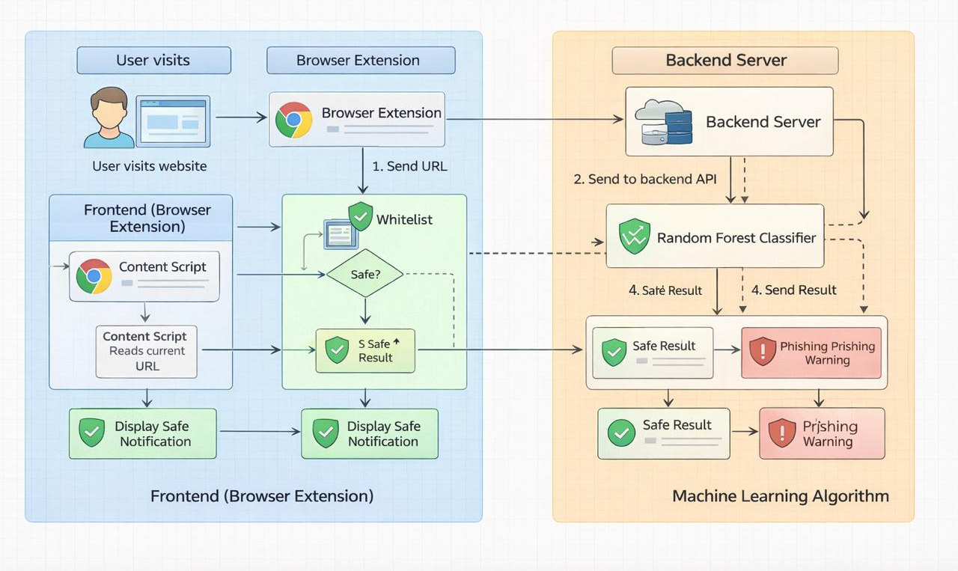

Fig 5.1 Architecture Design

USE CASE DIAGRAM
A Use Case Diagram is a visual representation of the interactions between users (actors) and the system. It shows the functional requirements of the system by depicting the various use cases (functions) that users can perform and how they interact with different components.

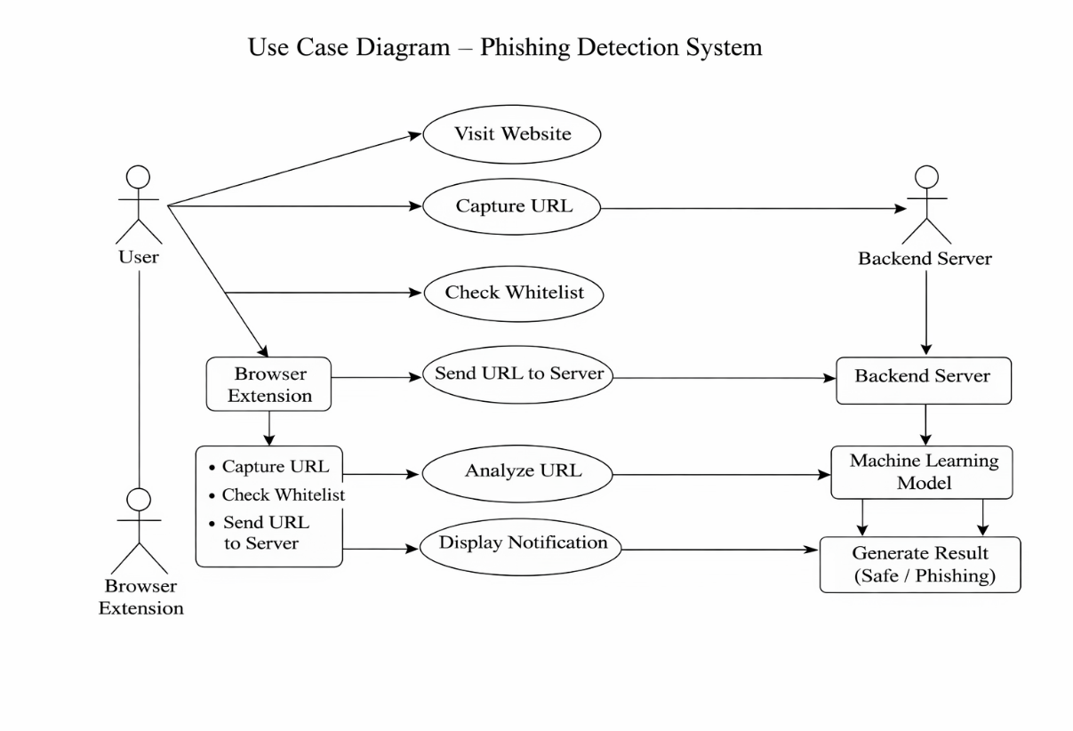

Fig 5.2 Use Case Diagram

SEQUENCE DIAGRAM
A Sequence Diagram illustrates the flow of messages between objects or components in the system over time. It represents the order of interactions required to complete a specific process or functionality, showing how objects communicate and in what sequence.

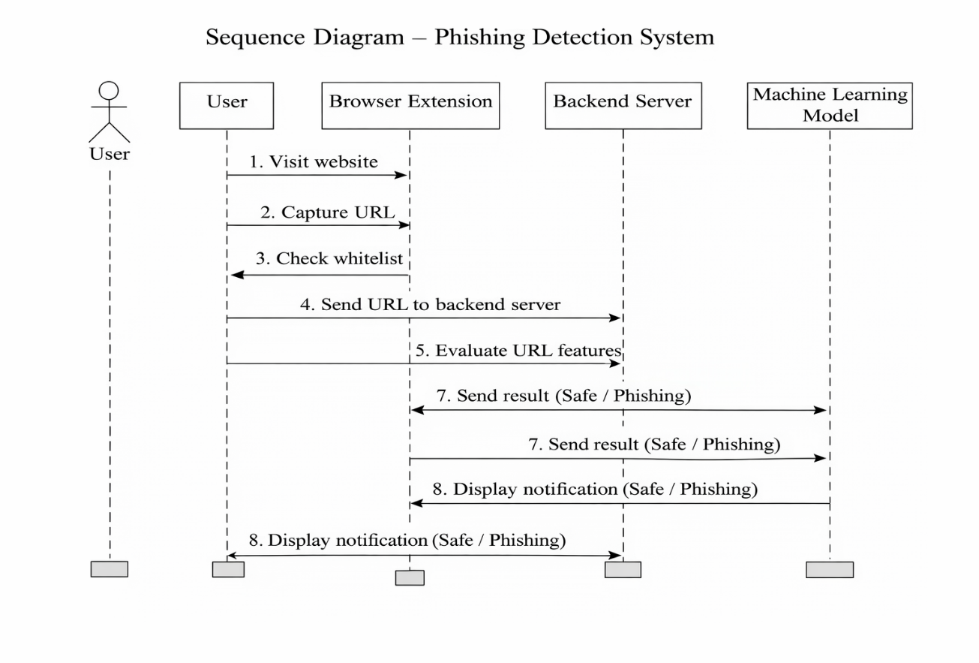
Fig 5.3 Sequence Diagram

ACTIVITY DIAGRAM
An Activity Diagram is a flowchart that models the workflow of a system or process. It shows the sequence of activities, decisions, and parallel processes, helping to visualize the logic of complex operations and the flow of control from one activity to another.

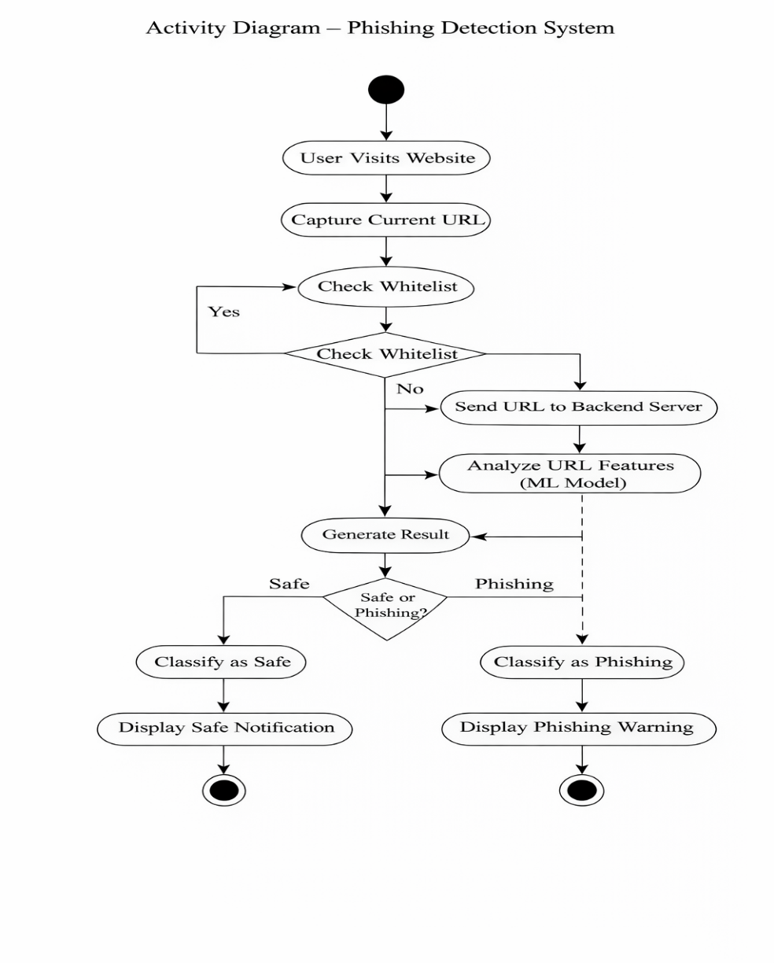
Fig 5.4 Activity Diagram

CHAPTER-6

IMPLEMENTATION
6.1 OVERVIEW

The implementation of the proposed system is designed to detect phishing URLs in real time using a combination of a browser extension, backend server, and a machine learning model. The system is divided into two main components: Frontend (Browser Extension) and Backend (Server with ML Model).

6.1.1. Frontend Implementation (Browser Extension)
The frontend is developed as a browser extension that continuously monitors user activity while browsing.
Modules in Frontend:
- Content Script:
Captures the current URL when the user visits a website.
- Whitelist Checker:
Checks whether the URL exists in a predefined safe list.
  - If found → Directly marked as safe
  - If not → Sent to backend for further analysis
- User Interface Module:
Displays notifications to the user:
  - Safe notification (Green indicator)
  - Phishing warning (Red alert)
Technologies Used:
- HTML, CSS, JavaScript
- Chrome Extension APIs

6.2 Backend Implementation (Server)
The backend server processes URLs received from the browser extension and interacts with the machine learning model.
6.2.1. Modules in Backend:
- API Endpoint:
Receives URL data from the frontend.
- Feature Extraction Module:
Extracts important features such as:
  - URL length
  - Presence of special characters
  - HTTPS usage
  - Domain age and DNS details
- Data Processing Unit:
Converts extracted features into a format suitable for model input.

6.3 Machine Learning Model Implementation
A Random Forest classifier is used for phishing detection due to its high accuracy and robustness.
6.3.1. Steps Involved:
- Dataset Collection:
URLs collected from sources like phishing databases and legitimate websites.
- Feature Engineering:
Important URL-based and domain-based features are extracted.
- Model Training:
  - Algorithm: Random Forest
  - Training split: 80:20
  - Cross-validation used for better accuracy
- Prediction:
The trained model classifies URLs as:
  - Safe
  - Phishing
6.4 Working Process
The system works as follows:
- User visits a website
- Browser extension captures the URL
- URL is checked with whitelist
- If not safe, URL is sent to backend server
- Backend extracts features and sends to ML model
- Model analyses and predicts result
- Result is sent back to frontend
- User receives notification (Safe / Phishing Warning)

6.5 Tools and Technologies Used
- Programming Languages: Python, JavaScript
- Frameworks: Flask / Node.js (Backend)
- Machine Learning: Scikit-learn
- Database: CSV / Dataset files
- Browser Extension: Chrome APIs

6.6 System Advantages (Implementation Level)
- Fast real-time processing
- Lightweight browser integration
- Scalable backend architecture
- Accurate detection using Random Forest

  - RUNNING BACKEND

CHAPTER-7

RESULT

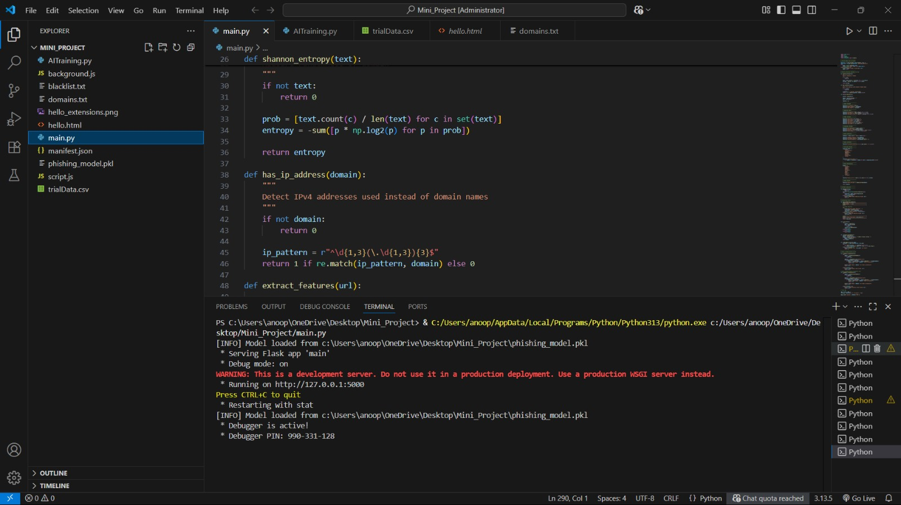

Fig.7.1 RUNNING BACKEND

TURNING EXTENSION ON



Fig.7.2 TURNING EXTENSION ON
  - VALIDATING WHEATHER URL IS SCAME OR NOT

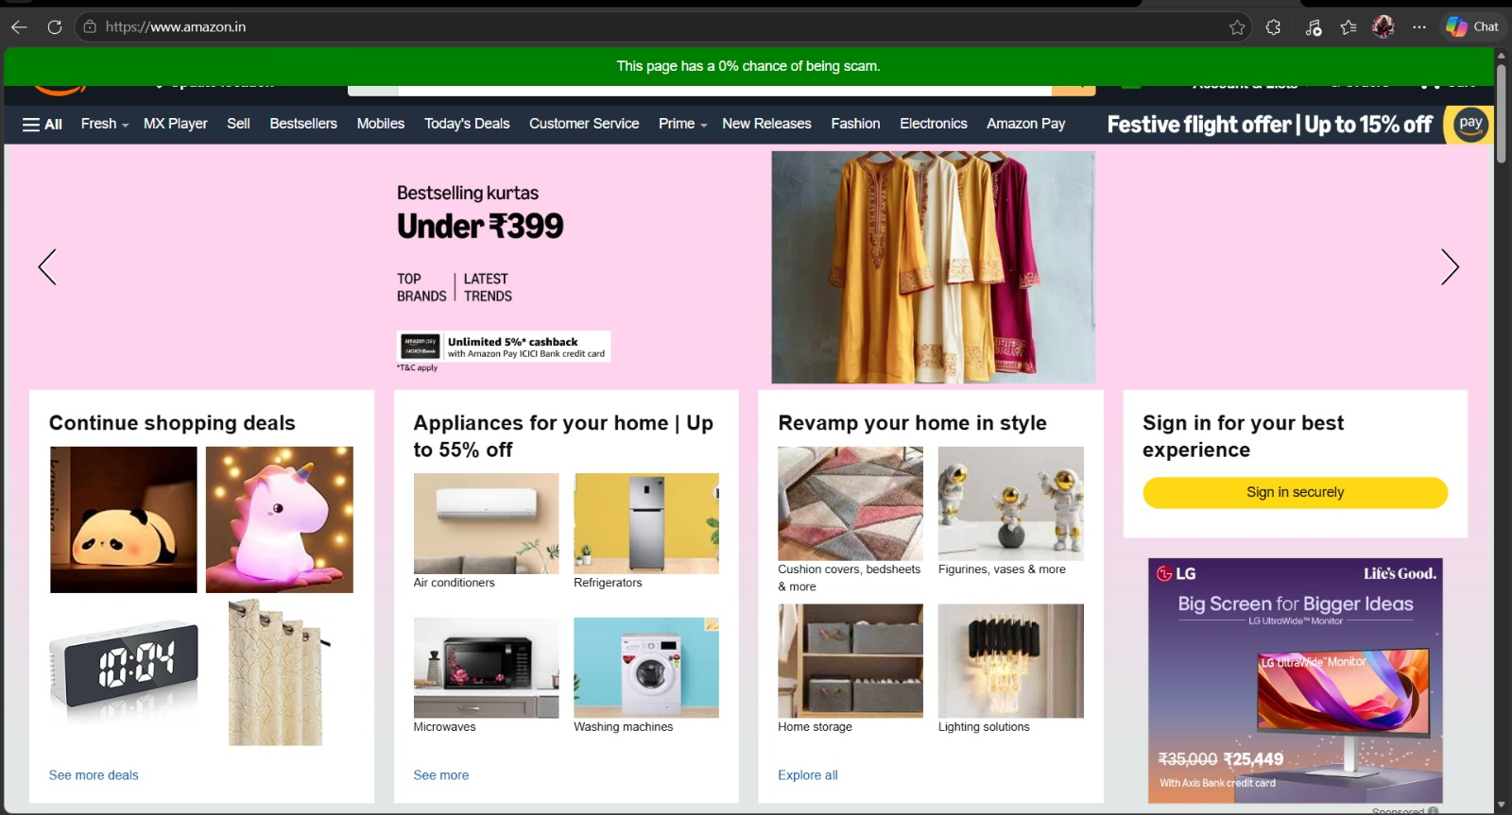

Fig.7.3 VALIDATING URL

Validating URL:
    - The given URL is safe to use.
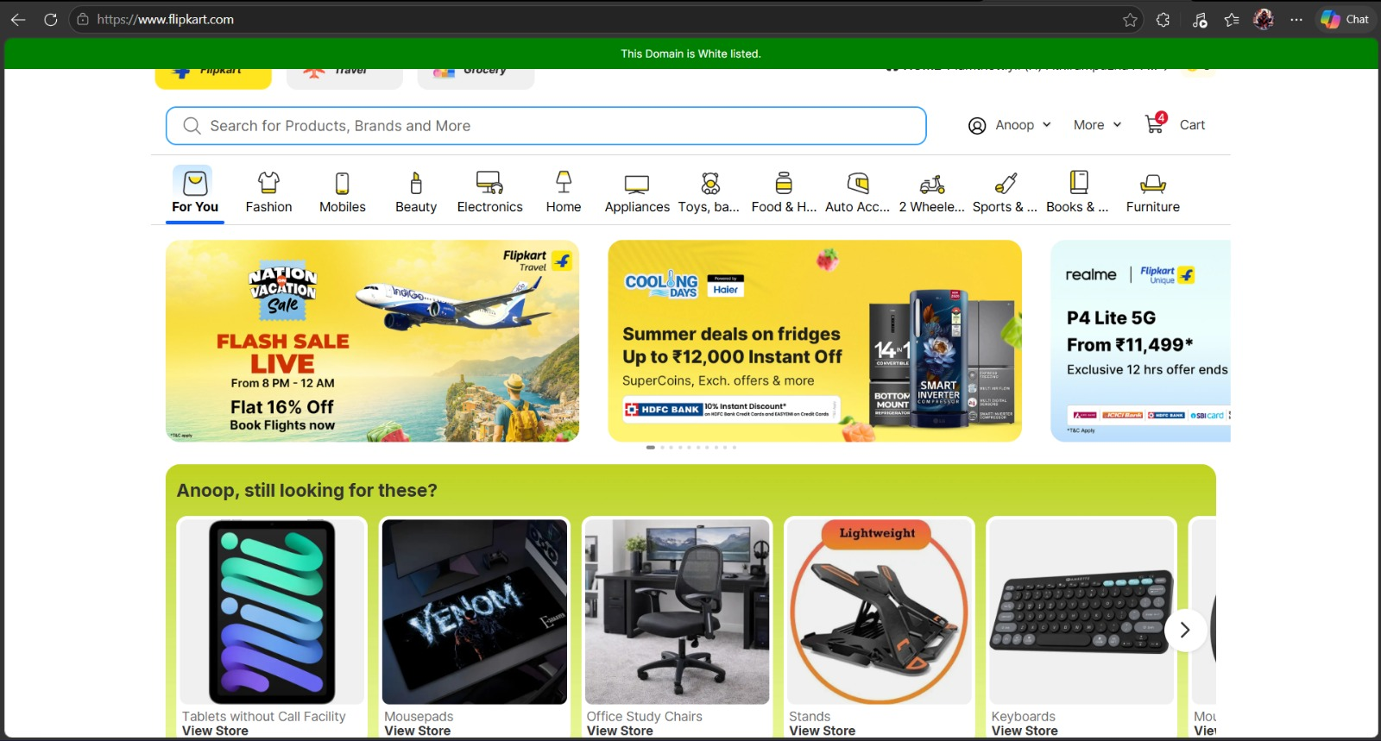

Fig.7.3.1 URL is safe

    - The given URL is not safe to use or it’s a scam


Fig.7.3.2 URL is scam

CHAPTER-8

FUTURE SCOPE
1. Integration of Advanced Deep Learning Techniques
The system can be enhanced by incorporating advanced deep learning models such as Long Short-Term Memory (LSTM) and Convolutional Neural Networks (CNN). These models can effectively capture complex and sequential patterns in URLs and web data, thereby improving the detection of sophisticated and previously unseen phishing attacks.

2. Content-Based Phishing Detection
The current system primarily focuses on URL-based analysis. In future, it can be extended to include content-based detection by analysing webpage elements such as HTML structure, JavaScript behaviour, forms, and embedded links. This will improve the identification of phishing websites that use legitimate-looking URLs.

3. Visual Similarity Detection
The integration of computer vision techniques can enable the system to detect phishing websites based on visual similarity. By comparing webpage layouts, logos, and design elements with legitimate websites, the system can identify fake interfaces and brand impersonation more effectively.

4. Cross-Platform Deployment
The system can be expanded into a cross-platform application, including mobile platforms such as Android and iOS. This will provide users with phishing protection across multiple devices and environments.

5. Continuous Learning and Model Updating
A continuous learning mechanism can be implemented to regularly update the machine learning model with new phishing data. This will ensure that the system remains adaptive and effective against emerging cyber threats.

6. Integration with Email and Messaging Platforms
Future enhancements may include integration with email clients and messaging platforms to detect phishing links in emails and messages in real time, thereby extending the system’s functionality.

7. Cloud-Based Deployment and Scalability
Deploying the system on cloud infrastructure can improve scalability, reliability, and processing speed. This will allow the system to handle large volumes of requests efficiently.

8. Performance Optimization
Further research can focus on improving the accuracy of the system by reducing false positives and false negatives through better feature selection, model tuning, and algorithm optimization.

CHAPTER-9

CONCLUSION
The project titled “Real-Time Phishing Link Detection using Machine Learning” presents an effective and reliable solution for identifying and preventing phishing attacks in real time. With the increasing growth of cyber threats, particularly phishing websites designed to steal sensitive user information, the need for an intelligent and automated detection system has become crucial. The proposed system utilizes a machine learning approach, specifically the Random Forest algorithm, to analyse various URL-based features such as URL length, domain characteristics, HTTPS usage, and special characters. By integrating this model with a browser extension, the system provides instant alerts to users while browsing, thereby enhancing user awareness and security. Unlike traditional blacklist-based methods, the system can detect previously unseen phishing URLs, making it more robust and adaptable. Although the system may face certain limitations such as dependency on feature extraction and the possibility of false predictions, it still demonstrates high accuracy and efficiency in phishing detection. Overall, the project contributes to improving cybersecurity by offering a scalable, real-time, and user-friendly solution that helps protect sensitive information and promotes safer internet usage.

CHAPTER-10

REFERENCES

1. PhishHaven – An Efficient Real-Time AI Phishing URLs Detection System
- Authors: Maria Sameen, Kyunghyun Han, Seong Oun Hwang
- Year: 2024
- Link: https://ieeexplore.ieee.org (search: PhishHaven phishing detection system)

2. Efficient Chrome Extension for Phishing Detection using Machine Learning (NoPhish)
- Authors: Leand Thaqi, Arbnor Halili, Kamer Vishi, Blerim Rexha
- Year: 2024
- Link: https://arxiv.org/abs/2409.10547

3. AI-Powered Fraud Detection in E-Commerce
- Authors: Manasa A S, Ashish L
- Year: 2024
- Link: https://www.researchgate.net (search: AI Powered Fraud Detection in E-Commerce Manasa Ashish)

4. E-Commerce Fraud Detection with Machine Learning
- Authors: Abed Mutemi, Fernando Bacao
- Year: 2024
- Link: https://www.researchgate.net (search: E-Commerce Fraud Detection Mutemi Bacao)

5. Vulnerability Evaluation in E-Commerce
- Authors: Mimi Wang, Zhijun Ding, Peihai Zhao
- Year: 2024
- Link: https://www.researchgate.net (search: Vulnerability Evaluation in E-Commerce Mimi Wang)

6. Secure E-Commerce Scheme
- Authors: Sena Efsun Cebeci, Kubra Nari, Enver Ozdemir
- Year: 2024
- Link: https://www.researchgate.net (search: Secure E-Commerce Scheme Cebeci)

7. AI-Enabled Comprehensive Survey of Phishing Attack Detection Techniques
- Author: Sivakumar Nagarajan
- Year: 2024
- Link: https://www.sciencedirect.com (search: AI Enabled Comprehensive Survey Phishing Detection)

8. Phishing Webpage Detection – Threat Landscape and Detection Techniques
- Authors: Aditya Kulkarni, Vivek Balachandran, Tamal Das
- Year: 2024
- Link: https://ieeexplore.ieee.org (search: Phishing Webpage Detection Kulkarni)

9. State of the Art in AI-Based Phishing Detection
- Authors: Mohammed Alghenaim, Gamal Alkawsi, Christopher R. Barnhart
- Year: 2025
- Link: https://ieeexplore.ieee.org (search: State of the Art AI Based Phishing Detection)

10. PhishNet: A Phishing Website Detection Tool using XGBoost
- Authors: Prashant Kumar, Kevin Antony, Deepakmoney Banga, Arshpreet Sohal
- Year: 2024
- Link: https://arxiv.org/abs/2407.04732

APPENDIX

CODE FOR FRONTEND

const serverUrl = 'http://127.0.0.1:5000/analyze';

function isIpHost(url) {
try {
const hostname = new URL(url).hostname;
const ipv4Pattern = /^(25[0-5]|2[0-4]\d|1\d\d|[1-9]?\d)(\.(25[0-5]|2[0-4]\d|1\d\d|[1-9]?\d)){3}$/;
return ipv4Pattern.test(hostname);
} catch (error) {
console.error('Invalid URL:', error);
return false;
}
}

function analyzePage() {
console.log("Started analyzing page...");
showLoadingBar();

if (isIpHost(window.location.href)) {
console.log('IP URL detected. Skipping API request.');
floodPageWithRed();
showAlertBar(90);
return;
}

fetch(serverUrl, {
method: 'POST',
headers: {
'Content-Type': 'application/json',
},
body: JSON.stringify({ url: window.location.href }),
})
.then(response => response.json())
.then(data => {
console.log('Analysis Result:', data);
removeLoadingBar();
console.log("okay,")
console.log(data.scamProbability)
if (data.scamProbability === -1) {
showSafeBar(data.scamProbability);
} else if (data.scamProbability > 50) {
floodPageWithRed();
showAlertBar(data.scamProbability);
} else {
showSafeBar(data.scamProbability);
}
})
.catch(error => {
console.error('Error analyzing page:', error);
console.log('Possible CORS issue or server error');
removeLoadingBar();
showErrorBar();
});
}

function showLoadingBar() {
const loadingBar = document.createElement('div');
loadingBar.id = 'scam-detector-loading';
loadingBar.innerText = 'Analyzing...';
loadingBar.style = 'position:fixed;top:0;width:100%;background:yellow;text-align:center;z-index:10000;padding:10px;';
document.body.appendChild(loadingBar);
}

function removeLoadingBar() {
const loadingBar = document.getElementById('scam-detector-loading');
if (loadingBar) {
document.body.removeChild(loadingBar);
}
}

function floodPageWithRed() {
const floodDiv = document.createElement('div');
floodDiv.id = 'scam-detector-flood';
floodDiv.style = 'position:fixed;top:0;left:0;width:100vw;height:100vh;background:red;opacity:0.5;z-index:9999;pointer-events:none;';
document.body.appendChild(floodDiv);
}

function showAlertBar(probability) {
const alertBar = document.createElement('div');
alertBar.id = 'scam-detector-alert';
alertBar.innerHTML = `<strong>Warning:</strong> This page has a ${probability}% chance of being a scam. <button id='scam-ignore-button'>Ignore</button>`;
alertBar.style = 'position:fixed;top:0;width:100%;background:red;color:white;text-align:center;z-index:10001;padding:10px;';
document.body.appendChild(alertBar);

document.getElementById('scam-ignore-button').addEventListener('click', () => {
removeFlood();
document.getElementById('scam-detector-alert').remove();
});
}

function showSafeBar(probability) {
const safeBar = document.createElement('div');
safeBar.id = 'scam-detector-safe';
if (probability === -1) {
safeBar.innerHTML = `This Domain is White listed.`;
} else {
safeBar.innerHTML = `This page has a ${probability}% chance of being scam.`;
}
safeBar.style = 'position:fixed;top:0;width:100%;background:green;color:white;text-align:center;z-index:10000;padding:10px;';
document.body.appendChild(safeBar);

setTimeout(() => {
if (safeBar) safeBar.remove();
}, 5000);
}

function showErrorBar() {
const errorBar = document.createElement('div');
errorBar.id = 'scam-detector-error';
errorBar.innerText = 'Error analyzing page. Please try again later.';
errorBar.style = 'position:fixed;top:0;width:100%;background:orange;color:black;text-align:center;z-index:10000;padding:10px;';
document.body.appendChild(errorBar);

setTimeout(() => {
if (errorBar) errorBar.remove();
}, 5000);
}

function removeFlood() {
const floodDiv = document.getElementById('scam-detector-flood');
if (floodDiv) {
floodDiv.remove();
}
}

analyzePage();

CODE FOR BACKEND (DETECTION MODEL)

from flask import Flask, request, jsonify
from flask_cors import CORS
import os
import pandas as pd
import numpy as np
import re
import joblib
import ipaddress
from urllib.parse import urlparse

# -----------------------------
# Load AI model once at startup
# -----------------------------
BASE_DIR = os.path.dirname(os.path.abspath(__file__))
MODEL_PATH = os.path.join(BASE_DIR, "phishing_model.pkl")
try:
model = joblib.load(MODEL_PATH)
print(f"[INFO] Model loaded from {MODEL_PATH}")
except Exception as e:
print(f"[ERROR] Failed to load model: {e}")
model = None

# -----------------------------
# Feature extraction (matches training)
# -----------------------------
def shannon_entropy(text):
"""
Measure randomness of domain
"""
if not text:
return 0

prob = [text.count(c) / len(text) for c in set(text)]
entropy = -sum([p * np.log2(p) for p in prob])

return entropy

def has_ip_address(domain):
"""
Detect IPv4 addresses used instead of domain names
"""
if not domain:
return 0

ip_pattern = r"^\d{1,3}(\.\d{1,3}){3}$"
return 1 if re.match(ip_pattern, domain) else 0

def extract_features(url):

parsed = urlparse(url)

domain = parsed.hostname or ""
path = parsed.path or ""

features = {}

# ---------------------------
# LENGTH FEATURES
# ---------------------------
features["url_length"] = len(url)
features["domain_length"] = len(domain)
features["path_length"] = len(path)

# ---------------------------
# CHARACTER COUNTS
# ---------------------------
features["num_digits"] = sum(c.isdigit() for c in url)
features["num_letters"] = sum(c.isalpha() for c in url)
features["num_special_chars"] = sum(not c.isalnum() for c in url)

# ---------------------------
# SYMBOL FEATURES
# ---------------------------
features["count_dot"] = url.count(".")
features["count_slash"] = url.count("/")
features["count_dash"] = url.count("-")
features["count_at"] = url.count("@")
features["count_question"] = url.count("?")
features["count_equal"] = url.count("=")

# ---------------------------
# STRUCTURAL FEATURES
# ---------------------------
features["num_subdomains"] = domain.count(".")
features["has_ip"] = has_ip_address(domain)
features["has_https"] = 1 if parsed.scheme == "https" else 0
features["has_at_symbol"] = 1 if "@" in url else 0

# ---------------------------
# DOMAIN COMPLEXITY
# ---------------------------
subdomain = domain.split(".")[0] if domain else ""

features["subdomain_length"] = len(subdomain)
features["num_hyphens_domain"] = domain.count("-")
features["num_words_domain"] = len(subdomain.split("-"))

# ---------------------------
# DOUBLE EXTENSION
# ---------------------------
features["has_double_extension"] = 1 if path.count(".") > 1 else 0

# ---------------------------
# SUSPICIOUS HOSTING
# ---------------------------
suspicious_hosts = [
"ngrok",
"trycloudflare",
"duckdns",
"000webhost",
"weebly",
"wixsite",
"workers.dev",
"serveo"
]

features["suspicious_host"] = (
1 if domain and any(host in domain for host in suspicious_hosts) else 0
)

# ---------------------------
# BRAND IMPERSONATION
# ---------------------------
brands = [
"facebook",
"paypal",
"google",
"amazon",
"microsoft",
"apple",
"bank",
"netflix",
"zoom",
"instagram"
]

features["brand_in_url"] = sum(b in url.lower() for b in brands)

# ---------------------------
# DOMAIN ENTROPY
# ---------------------------
features["domain_entropy"] = shannon_entropy(domain)

return features

# -----------------------------
# AI Model prediction
# -----------------------------
def analyze_url(url):
if model is None:
return 0
features = pd.DataFrame([extract_features(url)])
try:
prediction = model.predict(features)[0]
return int(prediction)
except Exception as e:
print(f"[ERROR] Model prediction failed: {e}")
return 0

# -----------------------------
# AI Detection Score
# -----------------------------
def spam_probability_value(url):
print("==========================================")
print("REPORT : ", url)
print("------------------------------------------")

# AI Model Detection
try:
print("Running AI Model Detection...")
is_phishing = analyze_url(url)
risk_score = 75 if is_phishing else 0
print(f"AI Model Detection = {risk_score}")
except Exception as e:
print(f"[ERROR] AI Detection failed: {e}")
risk_score = 0

print("------------------------------------------")
print(f"\nFinal Risk Score: {risk_score}\n")
print("==========================================")
return risk_score

def is_ip_url(url):
try:
parsed = urlparse(url)
host = parsed.hostname
if not host:
return False
ipaddress.ip_address(host)
return True
except ValueError:
return False
except Exception:
return False

def _normalize_hostname(url):
parsed = urlparse(url)
domain = (parsed.hostname or "").lower().strip().rstrip(".")
if domain.startswith("www."):
domain = domain[4:]
return domain

def _load_domain_list(file_name):
file_path = os.path.join(BASE_DIR, file_name)
try:
with open(file_path, "r", encoding="utf-8") as f:
return [line.strip().lower() for line in f if line.strip()]
except FileNotFoundError:
print(f"[WARNING] File '{file_path}' not found")
return []

# -----------------------------
# Check if domain exists in file
# -----------------------------
def is_domain_in_whitelist(url):
try:
domain = _normalize_hostname(url)
if not domain:
return False

domains = _load_domain_list("domains.txt")
for allowed_domain in domains:
if domain == allowed_domain or domain.endswith("." + allowed_domain):
print(f"[INFO] Domain '{domain}' found in whitelist")
return True

print(f"[INFO] Domain '{domain}' not found in whitelist")
return False

except Exception as e:
print(f"[ERROR] Domain check failed: {e}")
return False

# Check if domain exists in blacklist file
def is_domain_in_blacklist(url):
try:
domain = _normalize_hostname(url)
if not domain:
return False

domains = _load_domain_list("blacklist.txt")
for blocked_domain in domains:
if domain == blocked_domain or domain.endswith("." + blocked_domain):
print(f"[INFO] Domain '{domain}' found in blacklist")
return True

print(f"[INFO] Domain '{domain}' not found in blacklist")
return False

except Exception as e:
print(f"[ERROR] Blacklist check failed: {e}")
return False

# Flask App

app = Flask(__name__)
CORS(app, resources={r"/*": {"origins": "*"}})

@app.route('/analyze', methods=['POST'])
def analyze():
try:
data = request.get_json()
url = data.get('url')
if not url:
return jsonify({'error': 'URL is missing'}), 400

if is_ip_url(url):
risk_score = 90
elif is_domain_in_whitelist(url):
risk_score = -1

elif is_domain_in_blacklist(url):
risk_score = 100
else:
risk_score = spam_probability_value(url)

return jsonify({'scamProbability': risk_score})
except Exception as e:
return jsonify({'error': str(e)}), 500

@app.errorhandler(Exception)
def handle_exception(e):
return jsonify({"error": str(e)}), 500

if __name__ == "__main__":
app.run(port=5000, debug=True)

TRAINING MODEL

import pandas as pd
import numpy as np
import re
import joblib
from urllib.parse import urlparse
from sklearn.model_selection import train_test_split
from sklearn.ensemble import RandomForestClassifier
from sklearn.metrics import accuracy_score, classification_report
import matplotlib.pyplot as plt

# -----------------------------------------------------------
# HELPER FUNCTIONS
# -----------------------------------------------------------

def has_ip_address(domain):
"""
Detect IPv4 addresses used instead of domain names
"""
if not domain:
return 0

ip_pattern = r"^\d{1,3}(\.\d{1,3}){3}$"
return 1 if re.match(ip_pattern, domain) else 0

def shannon_entropy(text):
"""
Measure randomness of domain
"""
if not text:
return 0

prob = [text.count(c) / len(text) for c in set(text)]
entropy = -sum([p * np.log2(p) for p in prob])

return entropy

# -----------------------------------------------------------
# FEATURE EXTRACTION
# -----------------------------------------------------------

def extract_features(url):

parsed = urlparse(url)

domain = parsed.hostname or ""
path = parsed.path or ""

features = {}

# ---------------------------
# LENGTH FEATURES
# ---------------------------
features["url_length"] = len(url)
features["domain_length"] = len(domain)
features["path_length"] = len(path)

# ---------------------------
# CHARACTER COUNTS
# ---------------------------
features["num_digits"] = sum(c.isdigit() for c in url)
features["num_letters"] = sum(c.isalpha() for c in url)
features["num_special_chars"] = sum(not c.isalnum() for c in url)

# ---------------------------
# SYMBOL FEATURES
# ---------------------------
features["count_dot"] = url.count(".")
features["count_slash"] = url.count("/")
features["count_dash"] = url.count("-")
features["count_at"] = url.count("@")
features["count_question"] = url.count("?")
features["count_equal"] = url.count("=")

# ---------------------------
# STRUCTURAL FEATURES
# ---------------------------
features["num_subdomains"] = domain.count(".")
features["has_ip"] = has_ip_address(domain)
features["has_https"] = 1 if parsed.scheme == "https" else 0
features["has_at_symbol"] = 1 if "@" in url else 0

# ---------------------------
# DOMAIN COMPLEXITY
# ---------------------------
subdomain = domain.split(".")[0] if domain else ""

features["subdomain_length"] = len(subdomain)
features["num_hyphens_domain"] = domain.count("-")
features["num_words_domain"] = len(subdomain.split("-"))

# ---------------------------
# DOUBLE EXTENSION
# ---------------------------
features["has_double_extension"] = 1 if path.count(".") > 1 else 0

# ---------------------------
# SUSPICIOUS HOSTING
# ---------------------------
suspicious_hosts = [
"ngrok",
"trycloudflare",
"duckdns",
"000webhost",
"weebly",
"wixsite",
"workers.dev",
"serveo"
]

features["suspicious_host"] = (
1 if domain and any(host in domain for host in suspicious_hosts) else 0
)

# ---------------------------
# BRAND IMPERSONATION
# ---------------------------
brands = [
"facebook",
"paypal",
"google",
"amazon",
"microsoft",
"apple",
"bank",
"netflix",
"zoom",
"instagram"
]

features["brand_in_url"] = sum(b in url.lower() for b in brands)

# ---------------------------
# DOMAIN ENTROPY
# ---------------------------
features["domain_entropy"] = shannon_entropy(domain)

return features

# -----------------------------------------------------------
# LOAD DATASET
# -----------------------------------------------------------

print("Loading dataset...")

df = pd.read_csv("D:/CODING_CS/ReserchAndDevelopment/extension/Backend/trialData.csv") # columns: url,type

print(f"Loaded {len(df)} URLs")

# Convert labels
df["label"] = (df["type"] == "phishing").astype(int)

# -----------------------------------------------------------
# FEATURE EXTRACTION
# -----------------------------------------------------------

print("Extracting features...")

feature_rows = []

for i, url in enumerate(df["url"]):

feature_rows.append(extract_features(url))

if (i + 1) % 1000 == 0:
print(f"Processed {i + 1}/{len(df)}")

X = pd.DataFrame(feature_rows)
y = df["label"]

print("Feature extraction complete")

# -----------------------------------------------------------
# TRAIN / TEST SPLIT
# -----------------------------------------------------------

X_train, X_test, y_train, y_test = train_test_split(
X,
y,
test_size=0.2,
random_state=42,
stratify=y
)

print(f"Training samples: {len(X_train)}")
print(f"Testing samples: {len(X_test)}")

# -----------------------------------------------------------
# MODEL TRAINING
# -----------------------------------------------------------

print("Training RandomForest model...")

model = RandomForestClassifier(
n_estimators=500,
max_depth=30,
class_weight="balanced",
random_state=42,
n_jobs=-1
)

model.fit(X_train, y_train)

print("Model training complete")

# -----------------------------------------------------------
# EVALUATION
# -----------------------------------------------------------

y_pred = model.predict(X_test)

accuracy = accuracy_score(y_test, y_pred)

print(f"\nModel Accuracy: {accuracy:.4f} ({accuracy*100:.2f}%)\n")

print("Classification Report:\n")

print(classification_report(y_test, y_pred))

# -----------------------------------------------------------
# FEATURE IMPORTANCE
# -----------------------------------------------------------

importances = pd.Series(
model.feature_importances_,
index=X.columns
).sort_values(ascending=False)

print("\nTop 15 Important Features:\n")

print(importances.head(15))

# Plot feature importance

plt.figure(figsize=(10,6))

importances.head(15).plot(kind="bar")

plt.title("Top 15 Feature Importances")

plt.tight_layout()

plt.show()

# -----------------------------------------------------------
# SAVE MODEL
# -----------------------------------------------------------

joblib.dump(model, "phishing_model.pkl")

print("\nModel saved as phishing_model.pkl")

